**Bonding Heart Pattern**

**Guidance:**

* Bonding hearts should be made of 100% cotton.
* Please keep bonding hearts free of additional decorations (such as beads, buttons or bows), with no loose threads.

**Required:**

* Two pieces of patterned cotton fabric.
* Sewing needle
* Thread

**Instructions:**

Bonding hearts need to be approximately 20cm square, any smaller and they will become difficult to sew.

The template on the next page. will give you a heart shape of the correct size. Please print as many times as needed and cut out along with dotted line.

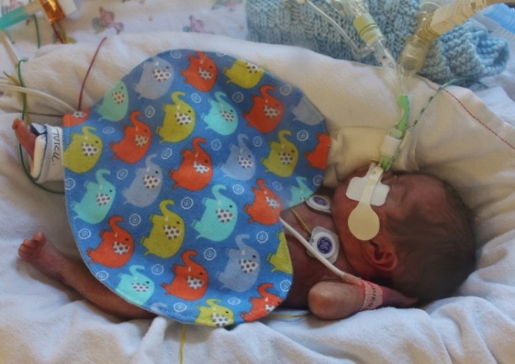You will need two ‘hearts’ of materials to make one bonding heart. These can then be sewn together.

**Please either arrange a drop off time or send all completed Bonding Hearts to:**

**Office Se6, Leah's Yard, Cambridge Street, Sheffield, S1 4HP**

