Knitted Flower: Forget Me Not Pattern

Required:
Knitting Needles 3mm or No 11
Blue and White double knitting wool
Button (optional)

Petals (Blue) – Cast on 6 stitches
Row 1 Knit to end of row
Row 2 Knit to end of row
Row 3 Knit 1, make 1 and knit to end of row
Row 4 Knit to end of row
Row 5 Knit 1, make 1 and knit to end of row (8 stitches)
Rows 6, 7, 8 Knit
Row 9 Knit 1, Knit 2 together through the back loop, knit to end of row
Row 10 Knit to end of row
Row 11 Knit 1, Knit 2 together through the back loop, knit to end of row
Row 12 Knit to end of row (6 stitches)
Row 13 Cast off 3 stitches, knit to end of row (3 stitches)
Row 14 Knit to end of row
Row 15 Cast on 3 stitches, knit to end of row
(You need to make 5 petals by repeating the pattern above)
Repeat Rows 2 – 15, 3 more times, then repeat rows 2 – 14 again.
Cast off leaving about 7” (approx. 18cm) of wool.

Middle of flower (White/Cream) - Cast on 3 stitches
Row 1 Knit to end of row
Row 2 Knit to end of row
Row 3 Knit 1, make 1, make 1, knit 1 (5 stitches)
Row 4 Knit to end of row
Rows 5, 6, 7, 8 Knit
Row 9 Knit 1, knit 2 together, knit 2 together (3 stitches)
Row 10 Knit to end of row
Row 11 Knit to end of row
Row 12 Cast off
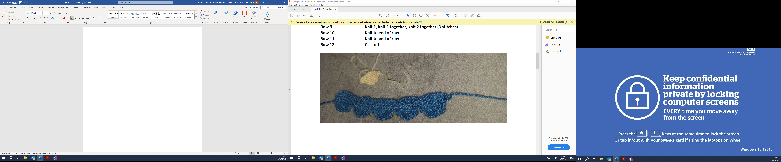
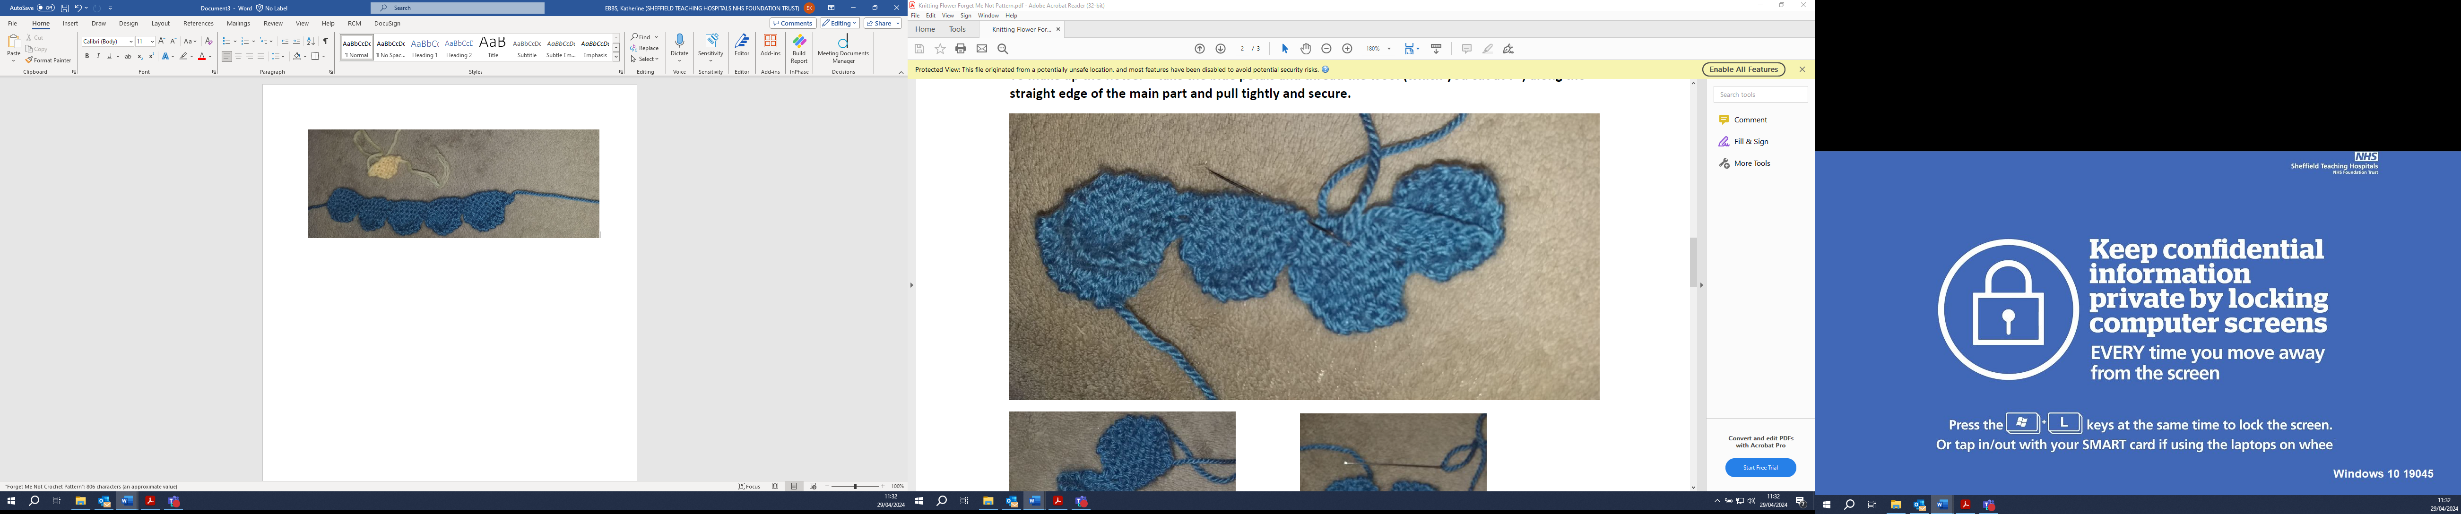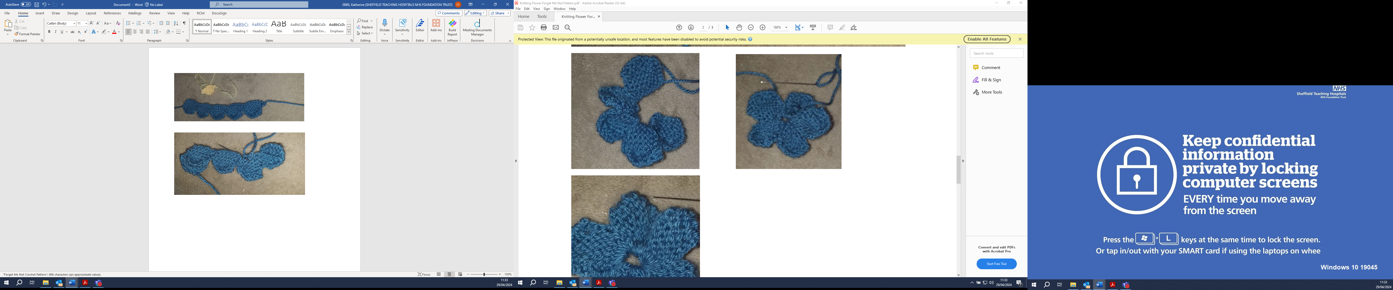
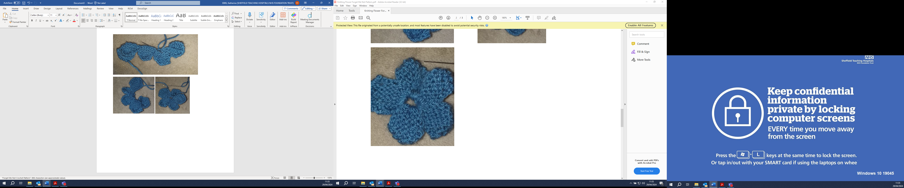
Sew white/cream middle into centre and pull tightly and secure.
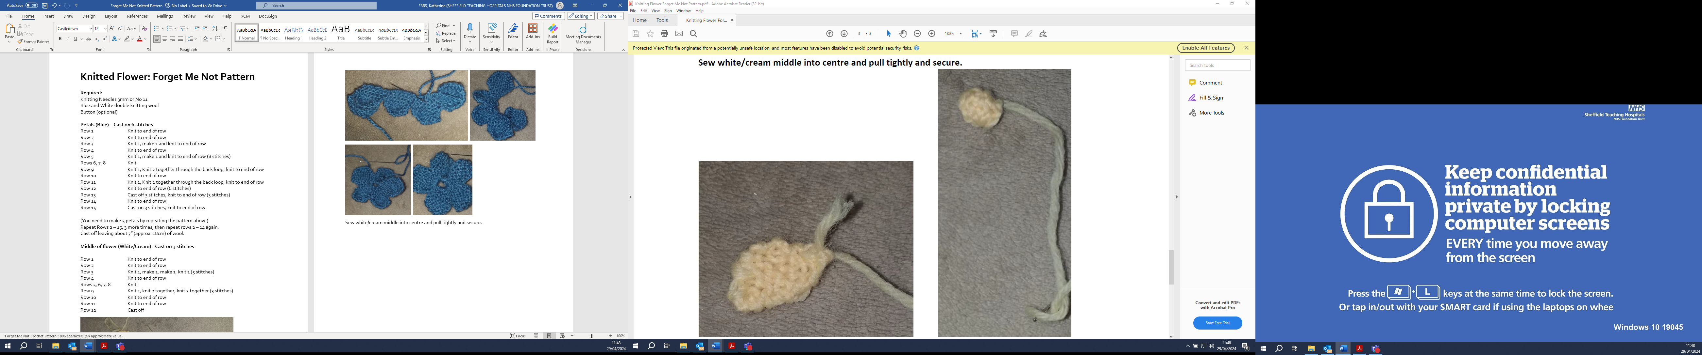
Draw this up, then sew into the centre
Completed flower
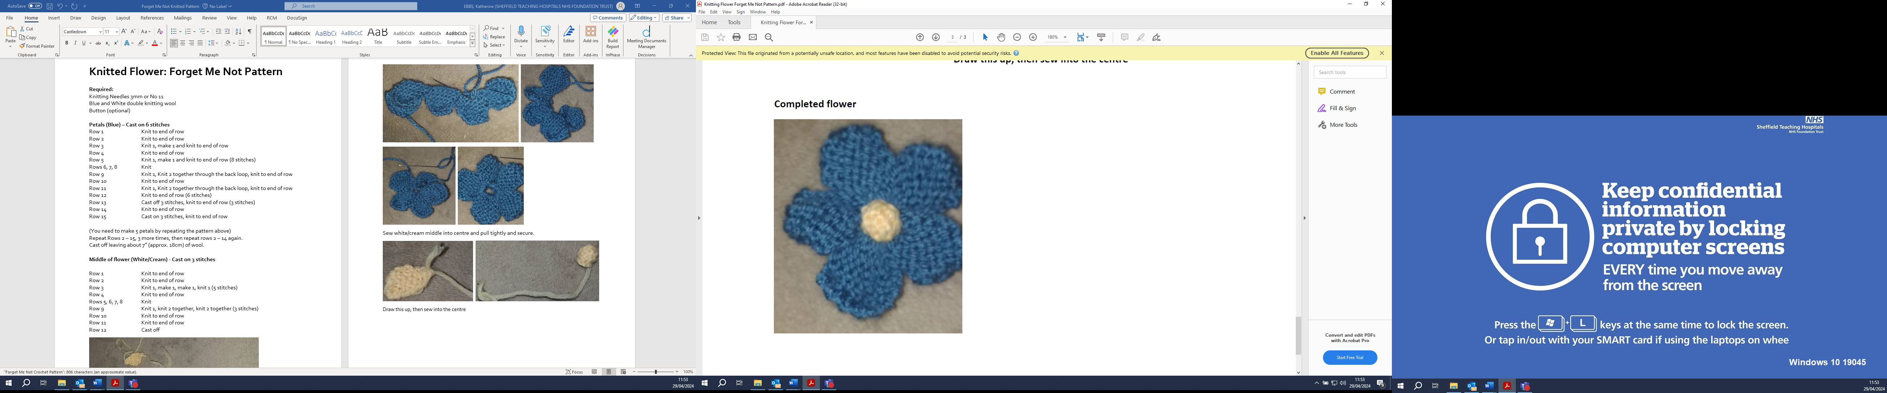

Please either arrange a drop off time or send all completed Forget Me Nots to:
Office Se6, Leah's Yard, Cambridge Street, Sheffield, S1 4HP

