**How to Crochet an Octopus**

**Guidance:**

Please use –

* 100% anti-allergenic cotton yarn only – we recommend 4 ply (you may use one or more colours for the body, bottom and tentacles in whatever combination you like).
* Scrap cotton yarn or embroidery thread for eyes, lips, and (optional) additional attributes.
* Anti-allergenic toy filling/stuffing, preferably washable at 60 degrees (it is important to make sure that the filling does not go through the stitches).

**Other Materials and Tools:**

* Hook 2.5/2mm and 3.25 mm / D / UK 11
* Darning needle
* Open-type stitch marker or a piece of thread (optional)

**Size of the finished octopus:**

Head should be 6-9 cm/ 2.5-3.5 inches from top to bottom

Tentacles should not be more than 22 cm / 8.5 inches when stretched

**Abbreviations:**

Ch – Chain

Dc – Double crochet

2Dc – Two Dc in one stitch

Dc2tog – Two Dc together

*…* (3) – Work instructions given between the asterisks three times

RD – Round

[10 sts] – Number of stitches after the certain round is finished

**Instructions**

**Body and tentacles:**

It is recommended to use a 2.5/2mm hook size for the body and a 3.25mm hook size for the tentacles.

RD 1 – 6 Dc in a magic ring mark beginning of the round with an open-type stitch marker or a thread (optional)

RD 2 – 2 Dc in every stitch [12 sts]

RD 3 – *1 Dc, 2 Dc* (6) [18 sts]

RD 4 – *1 Dc, 1 Dc, 2 Dc* (6) [24 sts]

RD 5 – *1 Dc, 1 Dc, 1 Dc, 2 Dc* (6) [30 sts]

RD 6 – *1 Dc, 1 Dc, 1 Dc, 1 Dc, 2 Dc* (6) [36 sts]

RD 7 –

| } 1 Dc in every stitch [36 sts]

RD 14

RD 15 – *4 Dc, Dc2tog* (6) [30 sts]

RD 16

| } 1 Dc in every stitch [30 sts]

RD 17

RD 18 – *3 Dc, Dc2tog* (6) [24 sts]

RD 19

| } 1 Dc in every stitch [24 sts]

RD 20

RD 21 – *2 Dc, Dc2tog* (6) [18 sts]

RD 22 – 1 Dc in every stitch [18 sts]

RD 23 – *7 Dc, Dc2tog* (2) [16 sts]

RD 24 – 1 Dc in every stitch [16 sts]

**RD 25 – Begin the arms:**

*1 Dc, 50 Ch, turn, 2 Dc in every chain, when done with the chain- 1 sl st in the next stitch* (8)

End with 1 slip stitch in the same stitch where the first arm began. Pull the yarn through.

If the tentacle does not want to twist, try making 3 or 4 Dc in every chain. Depending on a yarn, it might be sufficient to work 1 Dc in every chain in the return row, too.

If you wish to make your octopus more colourful, you can use different colours of yarn for its tentacles

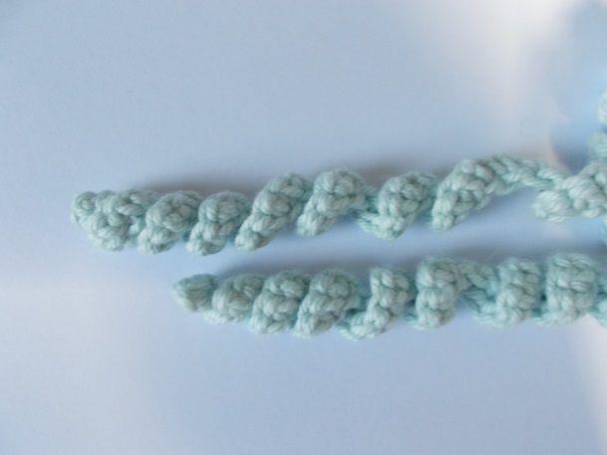

**Bottom:**

RD 1 – 5 Dc in a magic ring

RD 2 – 2 Dc in every stitch [10 sts]

RD 3 – *1 Dc, 2 Dc* (5) [15 sts]

Finish with a sl st and using the same yarn join the bottom piece with the body piece: with Dc by pulling up a loop through both the bottom piece stitch and the body-piece stitch. There should be two Dc like that per one tentacle. Weave in the ends.

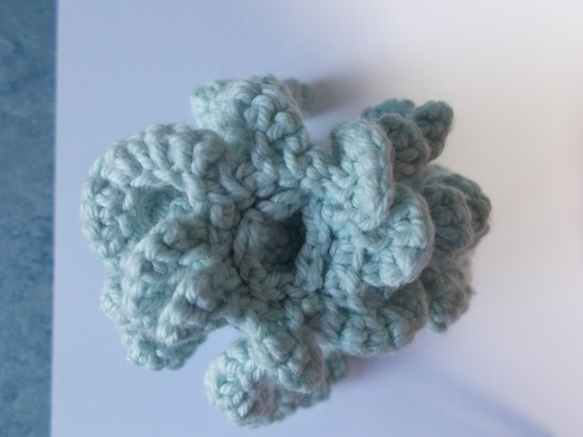

**Finishing touches:**

Using scrap yarn, embroider eyes and mouth.

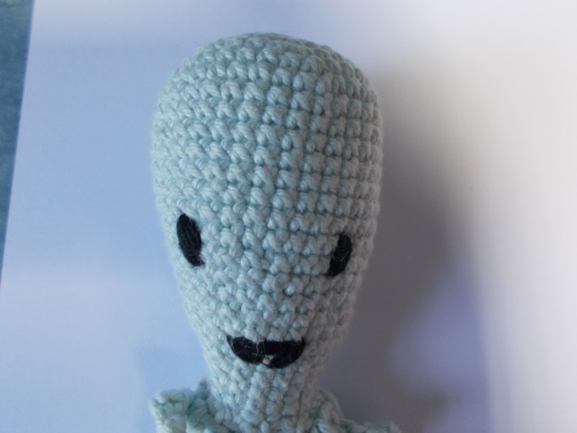

**Please either arrange a drop off time or send all completed Octopi to:**

**Office Se6, Leah's Yard, Cambridge Street, Sheffield, S1 4HP**