Crochet Twiddle Mitt/Muff Pattern

Guidance:
Please avoid using –
- Types of wool that can be easily pulled apart
- Any attachments less than 3cm in diameter
- Wide toothed zips
- Ribbons containing wire
- Pom poms
- Things that are brittle or can break easily, such as clay beads
All suitable embellishments must be very securely attached to withstand rough treatment.
Decorating with knitted/crocheted buttons or flowers is a good idea.
Consider lining the inside of a mitt with soft material (like fleece).
Consider sewing on a pocket for keeping a favourite photo, a spare hanky, or simply to amuse busy hands.

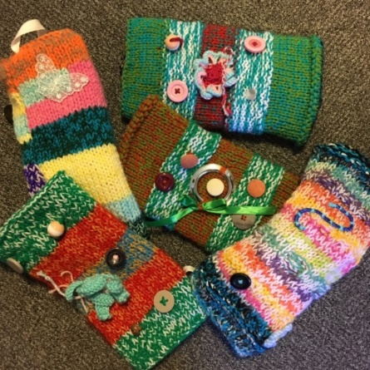
Stitches:
Ch – chain
Dc – double crochet
HTRB – half treble
TRB – treble crochet
DTRB – double treble
SS – slip stitch
rnd – round
st(s) – stitch(es)

Materials and Tools:
Aran Yarn (any colour as long as does not come apart)
8mm hook (or size required for tension)
6mm hook
Embellishments (e.g. buttons, ribbon, plaits, crocheted flowers, crocheted buttons – things that can be ‘twiddled’ and won’t break or come apart! Please avoid using ‘hairy’ wool that can come apart if tugged)

Instructions:
The muff is crocheted in two layers, which gives extra warmth. Each layer is worked in the round and in a spiral, so please do not join rounds unless instructed to do so.
Inner/Outer Sleeve: (make 2)
Chain 36 (40). Taking care not to twist the chain slip stitch into furthest chain from hook to make a ring.
Rnd 1 (RS): Ch 1 (does not count as first stitch), 1 HTRB in same Ch, 1 HTRB in each Ch to end of rnd, place marker if using, 36 (40) sts.
Rnd 2: 1 HTRB in each st to end, move marker to denote new end of rnd, 36 (40) sts.
Rnds 3-21: Repeat rnd 2.
Rnd 22: 1 HRTB in each st until 1 st remains, 1 Dc in next st, SS in next st.
Fasten off and break yarn leaving a long tail (at least 2 metres) for finishing off.
Decorate inner and outer sleeve:
Embellish each sleeve (e.g. buttons, ribbon, plaits, crocheted flowers, crocheted buttons – things that can be ‘twiddled’ and won’t break or come apart! Please avoid using ‘hairy’ wool that can come apart if tugged)
Button tab:
With 6mm hook Ch 4.
Row 1: 1 Dc in 2nd Ch from hook, 1 Dc in each of next 2 Ch, turn, 3 sts.
Row 2-6: Ch 1 (does not count as first st), 1 Dc in each st to end, turn.
Row 7: Ch 1 (does not count as first st), 1 Dc in next st, 1 Dc in chain space, 1 Dc in last st. Fasten off and weave in finishing tail.
Use starting tail to stitch tab in place on muff and sew a button on top.
Join inner and outer sleeves:
Turn the inner sleeve inside-out and slip it inside the outer sleeve. Make sure that you have one long yarn tail at either open end. Using 8mm hook and long yarn tail join the inner and outer sleeve together by working a round of Dc, working into the starting chain of one later and the final round of the other. Do this at each end to form a double-layered tube.
Weave in all ends.
Please check there are no loose threads and make sure that all the embellishments are sewn on tight so they cannot be pulled off – bear in mind that the pulling/twisting strength of an agitated patient may be stronger than you think! If in doubt, add a few more stitches to make things extra secure.

Thank you to Knitting for Charity for the pattern: Twiddle_muff.pdf (sth.nhs.uk)

Please either arrange a drop off time or send all completed Twiddle Mitts to:
Office Se6, Leah's Yard, Cambridge Street, Sheffield, S1 4HP

