Knitted Twiddle Mitt/Muff Pattern

Guidance:
Please avoid using –
- Types of wool that can be easily pulled apart
- Any attachments less than 3cm in diameter
- Wide toothed zips
- Ribbons containing wire
- Pom poms
- Things that are brittle or can break easily, such as clay beads
All suitable embellishments must be very securely attached to withstand rough treatment.
Decorating with knitted/crocheted buttons or flowers is a good idea.
Consider lining the inside of a mitt with soft material (like fleece).
Consider sewing on a pocket for keeping a favourite photo, a spare hanky, or simply to amuse busy hands.
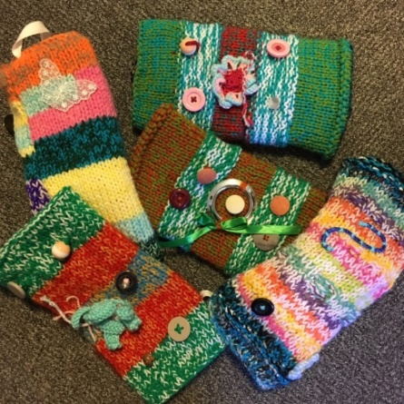
Materials and Tools:
Knitting Needles (size varies depending on the weight of the yarn you’re using)
Wool (any as long as it doesn’t come apart easily)
Embellishments (e.g. buttons, ribbon, plaits, crocheted flowers, crocheted buttons – things that can be ‘twiddled’ and won’t break or come apart! Please avoid using ‘hairy’ wool that can come apart if tugged)

Instructions:
Cast on 40 stitches using 2 strands of yarn or 1 strand of chunky wool
Use stocking stitch (knit a line, purl a line) for 11 inches (28 cm)
Continue with stocking stitch and use up any oddments of various textures of wool. Knit until it measures 23 inches (58.5cm). Cast off
To finish the mitt, neatly sew the long edges together with purl side facing you. Turn the mitt inside out and push the cuff up inside the mitt body (doubling the mitt) and neatly sew the cast on and cast off edges together.
To decorate the mitt, try to include at least six decorations on the outside, and four on the inside. You can add more if you like!
Add a loop to the outside of the mitt by using 8 inches (20 cm) of nylon thread or ribbon. Push the thread or ribbon through the top section of the mitt and tie a knot in it. Then pull the knot through so that it is hidden inside the mitt. The loop is needed so that the patients name tag can be kept on the mitt.
Please check there are no loose threads and make sure that all the embellishments are sewn on tight so they cannot be pulled off – bear in mind that the pulling/twisting strength of an agitated patient may be stronger than you think! If in doubt, add a few more stitches to make things extra secure.

Please either arrange a drop off time or send all completed Twiddle Mitts to:
Office Se6, Leah's Yard, Cambridge Street, Sheffield, S1 4HP

